Dear Retailer:

As a business person in your community, you can help Oregon Profit by preventing access to alcohol by minors. Our state profits from alcohol-free youth in a number of ways:
- Reduced youthful access to alcohol can reduce underage drinking in general.
- Reduced underage drinking results in improved overall health of young people.
- Improved health of young people leads to lower health care costs, greater productivity of our next generation of workers, and more.

There is an ongoing increase in efforts throughout (community), (county), and the state of Oregon to encourage responsible alcohol sales according to the laws of our state. The majority of Oregonians support the laws surrounding alcohol and minors and want to see them enforced. Enclosed in this packet is a copy of the (community) Community Proclamation. A broad and diverse group of organizations and individuals, including (endorsers) have gone on record as supporting not selling or providing alcohol to minors.

As part of a project called Reducing Youth Access to Alcohol, Oregon Research Institute will be conducting Reward & Reminder visits in alcohol outlets in your community. A trained 21-year old volunteer will enter a store and attempt to buy alcohol. If the employee does not ask for ID before making the sale, a reminder letter will be handed to them. If the employee asks for ID before selling, a gift certificate and congratulatory letter will be given. The intent of this activity is to positively reinforce employees who ask to see identification when a young person attempts to purchase alcohol.

In addition, Oregon Liquor Control Commission (OLCC) will be conducting random and unannounced inspections with retailers throughout the state to ensure there are no alcohol sales to individuals under 21 years old. Salespersons found in violation can be fined anywhere from $1,650 to $4,950.

Reward & Reminder activities, compliance checks and other enforcement activities are an important part of reducing youth access to alcohol. When we reduce the availability of alcohol to young people, we also help to reduce the problems associated with underage drinking such as car crashes, vandalism, assault, and date rape, just to name a few.

If we can delay the onset of drinking in young people, we can impact their health later on in life. We know that people who begin drinking before age 15 are four times more likely to develop alcoholism than those who begin at age 21. (NIAAA news release, 1/14/98).

If you have any questions about this project please contact me at Oregon Research Institute
(541)484-2123. We realize that most alcohol retailers want to act responsibly and comply with the law and we thank you up front for your consideration and attention to this matter.
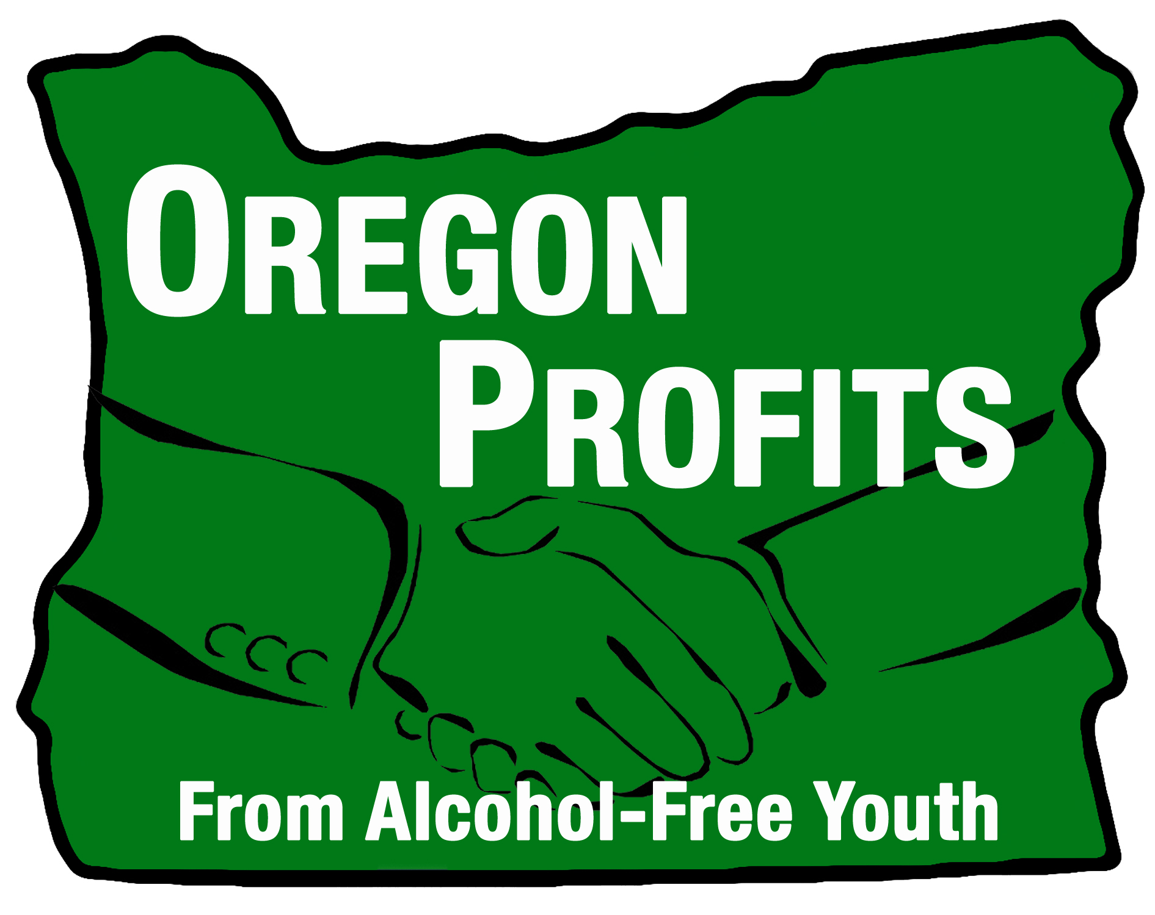
Sincerely,

Anne Kraft, Oregon Research Institute, 1715 Franklin Blvd.,
Eugene, OR 97403, (541)484-2123, annek@ori.org

